MAYOR’S OFFICE OF HOUSING AND COMMUNITY DEVELOPMENT
CITY AND COUNTY OF SAN FRANCISCO

REQUEST FOR PROPOSALS – Capital Projects

December 2016

This is a continuous RFP for program years 2016-2017 and 2017-2018, for which proposals are accepted on an ongoing basis and will be reviewed according to the schedule listed in this document.

One original and three copies of the completed proposal should be submitted to:
Mayor’s Office of Housing and Community Development
1 South Van Ness Avenue, 5th Floor
San Francisco, CA 94103
Attention: Brian Cheu

HAND DELIVERY RECOMMENDED

In addition, please e-mail a PDF of the completed application to brian.cheu@sfgov.org by that same deadline.

REQUEST FOR PROPOSALS (RFP) OVERVIEW

The Mayor’s Office of Housing and Community Development (MOHCD) announces that Community Development Block Grant (CDBG), Housing Trust Fund – Complete Neighborhoods Program (CNP) and South of Market Community Stabilization Fund (SoMa Fund) funding are being made available to community-based organizations for capital improvements to public facilities.

Review Process and Schedule
Proposals will be accepted on an ongoing basis for program years 2016-2017 and 2017-2018. MOHCD will review proposals and make funding available according to the following schedule. MOHCD reserves the right to adjust the schedule at its discretion.

Proposals must be received by: | 2/1/2017 | 8/1/2017 | 2/1/2018
Awards will be made by: | 3/1/2017 | 9/1/2017 | 3/1/2018
For grants starting on: | 4/1/2017 | 10/1/2017 | 4/1/2018

All proposals received by 5:00 pm on the due date indicated above will be initially screened by a committee composed of MOHCD staff to determine completeness and eligibility. Ineligible proposals will be eliminated at this stage. MOHCD staff will evaluate all complete and eligible proposals and make funding decisions.

Technical Assistance Workshops
Questions on completing the application can be addressed at any of the technical assistance workshops that MOHCD will conduct. The technical assistance workshops will assist interested applicants in determining eligibility and completing the required elements of the proposal package. Potential applicants are highly encouraged to attend one of the workshops before submitting an application, as this is a new process for funding Capital Projects. A workshop was recently held on December 12, 2016 for the cycle in which proposals are due on February 1, 2017. Two more workshops will be held prior to the other two proposal due dates. The dates for those workshops are to be determined.

The meeting room is wheel chair accessible. If you need translation services, a sign language interpreter, or any other accommodations, please call 415-701-5598 at least 72 hours in advance. For speech/hearing impaired callers, please call TYY/TDD 415-701-5503. For information on MUNI routes, please call 415-673-6864.

Proposal Evaluation Criteria

Evaluation Metric | Criteria for an Excellent Response | Funding Source
 |  | CDBG | SoMa Fund | CNP
Alignment with Funding Source Objectives and RFP Program Priorities | Project aligns with the program objectives of the CDBG, SoMa Fund and/or CNP programs and with the RFP program priorities. | x | x | x
Project Eligibility | The extent to which programs benefiting from the capital project meet eligibility requirements | x | x | x
Connection to Vulnerable Populations | Benefitting program(s) primarily serve vulnerable population(s) as identified in MOHCD's 2015-2019 Consolidated Plan: Recent immigrants, TAY, seniors, public housing residents, homeless, people living with HIV/AIDS, survivors of domestic violence, people with disabilities, veterans, re-entry populations, LGBTQQ individuals, African-Americans, Native Americans | x
Connection to Priority Populations | Project is designed with the SoMa Community Stabilization Fund’s priority populations in mind. |  | x
Connection to Neighborhood Revitalization Strategy Areas (NRSA) | Benefitting programs primarily serve NRSAs as identified in MOHCD’s 2015-2019 Consolidated Plan: Bayview Hunters Point, Visitacion Valley, Mission, South of Market, Chinatown, and Tenderloin. | x
Serves the South of Market Neighborhood | Project must be located within the boundaries of SoMa and serve primarily residents living within the boundaries of SoMa |  | x
Matching Funds | Project has matching funds. | x | x
Agency Capacity | 1) Proposal details staff that have relevant construction experience; and,  2) For agencies that have current Capital grants, the applicant demonstrates the ability to manage multiple projects well. | x | x | x
Project Readiness and Feasibility | 1) The project is planned and ready for implementation (e.g., has site control);  2) Plan/project design and implementation schedule are reasonable and realistic; and,  3) Budget is detailed, appropriate and realistic; and, includes only eligible expenses. | x | x | x
Capital Needs Assessment | Building has a current Capital Needs Assessment (CNA) | x | x
Project Need | The project addresses neighborhood needs identified in official City agency planning or strategy documents, and/or meets neighborhood needs identified through a City Planning development review process for a specific project or a set of projects. |  |  | x
Collaboration and Community Support | 1) The project shows financial and/or in-kind participation from residential developer(s);  2) The project shows the involvement of neighborhood residents planning and/or implementing the project; and,  3) The project shows support from neighborhood residents. |  |  | x
Accessibility | The project is broadly accessible to local residents e.g., located in places or buildings that allow attendance and participation by a broad cross-section of community members where such projects may be widely used. |  |  | x
Sustainability | 1) The project demonstrates long term (at least five years) site control and shows a maintenance plan of at least five years; and,  2) The project plans for or uses sound ecological principals (e.g., native landscaping, use of reused and recycled materials, energy conservation, etc., plans for waste removal during and after project, etc.). |  |  | x
Evaluation | 1) The project demonstrates a robust evaluation methodology; and,  2) The project outlines specific, measurable and realistic outcomes for the project and reflects best practices. |  |  | x

Protest Procedures

Protest of Non-Responsiveness Determination
Within five business days of the City's issuance of a notice of non-responsiveness, any respondent that has submitted a proposal and believes that the City has incorrectly determined that its proposal is non-responsive may submit a written notice of protest. Such notice of protest must be received by the City on or before the fifth business day following the City's issuance of the notice of non-responsiveness. The notice of protest must include a written statement specifying in detail each and every one of the grounds asserted for the protest. The protest must be signed by an individual authorized to represent the respondent, and must cite the law, rule, local ordinance, procedure or RFP provision on which the protest is based. In addition, the protestor must specify facts and evidence sufficient for the City to determine the validity of the protest.

Protest of Grant Award
Within five business days of the City's issuance of a notice of intent to award the grant, any firm that has submitted a responsive proposal and believes that the City has incorrectly selected another proposer for award may submit a written notice of protest. Such notice of protest must be received by the City on or before the fifth business day after the City's issuance of the notice of intent to award.

The notice of protest must include a written statement specifying in detail each and every one of the grounds asserted for the protest. The protest must be signed by an individual authorized to represent the proposer, and must cite the law, rule, local ordinance, procedure or RFP provision on which the protest is based. In addition, the protestor must specify facts and evidence sufficient for the City to determine the validity of the protest.

Delivery of Protests
All protests must be received by 5:00 p.m. of the due date. If a protest is mailed, the protestor bears the risk of non-delivery within the deadlines specified herein. Protests should be transmitted by a means that will objectively establish the date the City received the protest. Protests or notice of protests made orally (e.g., by telephone) or via e-mail will not be considered.

If the City determines that a meeting with the party submitting the appeal is necessary, such meeting will be scheduled within ten (10) calendar days of the receipt of a protest to review and attempt to resolve the protest. Protests must be delivered to:

Brian Cheu, Director of Community Development
Mayor’s Office of Housing and Community Development
1 South Van Ness Ave., 5th Floor
San Francisco, CA 94103

GENERAL REQUIREMENTS

Alignment with 2015-2019 Consolidated Plan
Proposed program must achieve one of the following three overarching objectives as identified in the 2015-2019 Consolidated Plan:
- Families and individuals are stably housed;
- Communities have healthy, physical, social and business infrastructure; and,
- Families and individuals are resilient and economically self-sufficient.

For further background information, please review the 2015-2019 Consolidated Plan at
http://www.sfmohcd.org/index.aspx?page=1346.

Eligible Applicants
Eligible applicants include:
- 501(c)(3) registered non-profit corporations, or have a fiscal sponsor with a (501)(c)(3) tax status, with proposed program based in San Francisco; The organization with 501(c)(3) tax status must be in good standing with the State of California’s Registry of Charitable Trusts; Capital Projects applicants may include a limited partnership whose managing general partner is a 501(c)(3) non-profit corporation;
- Churches and religious organizations that meet the requirements of IRC section 501(c)(3), regardless of their application and recognition from the IRS; and,
- Governmental entities, including public agencies, commissions or authorities that are independent of the City and County of San Francisco’s government. Governmental entities are not eligible for CNP funding.

All community-based organizations must become City-approved vendors before receiving funding. Organizations that are not yet City-approved vendors should begin the certification process as soon as possible in order to ensure that they are able to meet this requirement if awarded a grant. The City’s Office of Contract Administration offers all of the necessary forms on their website, which can be found at http://sfgsa.org/index.aspx?page=4762. Subcontractors are not required to be City-approved vendors; only the lead organization or fiscal sponsor must be City-approved.

Organizational Capacity
The applicant agency must demonstrate by its history and track record that it can efficiently and effectively administer programs to achieve desired outcomes. There should be evidence of the ability to fundraise. The proposal should demonstrate a logical relationship between the organization, its mission, and the proposed project. Agencies that have been suspended or were unable to successfully complete a MOHCD program or project during the period of July 2013 through June 2016 must provide additional supportive information on enhanced ability to manage/implement projects. Funding preference is given to agencies demonstrating superior performance and the ability to leverage funds from non-City sources.

MOHCD will consider the applicant’s prior performance including timely completion of previous projects supported by City funds within the agreed upon schedules and budgets, and full compliance with the terms of any previous grant/financing agreements, including the timely submittal of Monthly Project Updates, Annual Monitoring Reports and payment of residual receipts if applicable. MOHCD will not proceed with a funding recommendation until the applicant is in compliance.

Board of Directors
The applicant agency should have a Board of Directors with a minimum of 7 members. The Board and staff must have broad based experience and skills to satisfactorily manage and guide the organization. The Board of Directors must provide vision, oversight and direction to the organization. The Board of Directors should include San Francisco residents or demonstrate knowledge of the needs of low and moderate income San Franciscans. Representation on the board of low income residents and from the target neighborhood and/or population is encouraged.

Funding Sources
Capital projects may be supported by Community Development Block Grant (CDBG) funds, South of Market Community Stabilization Fund (SoMa Fund) or Housing Trust Funds - Complete Neighborhoods Program (CNP).

These criteria are intended to provide guidance for applicants depending upon the specific funding source applied for. Please note that applicants should review the requirements and strategies described below if the applicant intends to submit a proposal under that funding source. The goals and recommendations included below reflect the most relevant items, but are not intended to be a comprehensive summary of all of the requirements for each funding source.

Community Development Block Grant (CDBG)
CDBG activities must meet at least one of following three national objectives:
- Principally benefit low and moderate-income persons; OR,
- Eliminate slums and blight; OR,
- Meet an urgent need (such as earthquake recovery).

Most, if not all, CDBG applications tend to qualify under the first objective. Under the low- and moderate-income national objective, program beneficiaries must be low- or moderate-income. CDBG regulations define a low- and moderate-income person as a member of a family that has an income equal to or less than the Section 8 low-income limit established by HUD. Unrelated individuals shall be considered as one-person families for this purpose. For more information, please review the HUD income level chart in the RFP Attachment.

Proposed capital projects for CDBG funding must improve the infrastructure and physical environment of San Francisco neighborhoods, especially in those neighborhoods with high concentrations of low- and moderate-income residents.

South of Market Community Stabilization Fund (SoMa Fund)
The purpose of the SoMa Community Stabilization Fund is to stabilize the community and promote equity through funding recommendations and priorities that mitigate the impact of development in the South of Market neighborhood (SoMa). All funded projects must be located within the boundaries of Embarcadero Street to the east, Townsend Street to the south, Market Street to the North and South Van Ness and Division Streets to the west (see SoMa Fund map in the RFP Attachment) and serve residents living within those geographical boundaries. Projects funded by the SoMa Community Stabilization Fund must qualify under at least one of the following four areas:

Housing – Increase access to perpetually affordable housing opportunities for existing residents of SoMa by investing in:
- resident engagement and leadership development
- services to provide information and preparation to successfully compete for affordable units
- Invest in acquisition, rehabilitation and/or development of land and property (Leveraging of funds required)
Jobs and Income – Support economic and workforce development for low income residents and community serving businesses by investing in:
- employer cultivation
- job preparation
- income support through micro business
- asset development
- mentoring, leadership development and financial literacy programs for youth and families
Community Cohesion and Neighborhood Communication – Strengthen community networks and infrastructure to build neighborhood unity, self-determination and equity in SoMa; Preserve the social heritage of the neighborhood by investing in:
- local nonprofit community infrastructure development
- neighborhood culture and arts that preserve existing neighborhood social heritage of the neighborhood
- fostering resident connections across culture and income
Physical Infrastructure - Improve the infrastructure and physical environment of the neighborhood by invest in:
- Rehabilitation, acquisition and/or development of community facilities
- improving public spaces and outdoor facilities to promote cohesion among diverse groups in the neighborhood

Local Housing Trust Fund – Complete Neighborhoods (CNP)
The Complete Neighborhoods Program (CNP) will make it possible for new residential development to be a catalyst for bringing more community improvement projects to their surrounding neighborhoods to benefit all neighborhood residents. Complete Neighborhoods projects will be accessible to new neighborhood residents associated with new residential developments and to existing neighborhood residents. Program objectives include:
- fostering stronger relationships between residential developers, community-based organizations and neighborhood groups; and,
- environmental and service improvements in neighborhoods experiencing residential growth.

Residential developers and neighborhood groups will jointly apply for project funding. Funded projects must be related to residential development projects in the entitlement and construction process OR to residential developments built within the past three years. Residential developers are expected to contribute to the planning and/or the development of a community improvement project through financial or in-kind contributions.

ELIGIBLE PROJECTS AND PROGRAM OBJECTIVES/PRIORITIES

Eligible Projects

For CDBG: Acquisition and construction funding is available for community facilities that:
- Serve low- and moderate-income residents and are open to the general public during normal hours of operation; and,
- Maintain eligible services for a period of five, ten, twenty, thirty years following the completion of construction, according to the tenure period tables below.

For CNP: A project must:
- Have as partners in the application, a for-profit or non-profit residential developer and a non-profit community-based organization or a non-profit neighborhood group. A neighborhood group that does not have non-profit status can be a project co-applicant as long as it uses a 501(c)(3), registered non-profit corporation as its fiscal sponsor;
- Be accessible to members of the general public for minimal or no fee or, in the case of improvements to child care facilities, where a majority of the childcare slots will be affordable to children from households with low and or moderate incomes;
- Be related (tied) to a residential development project of at least five units that is currently in the process of receiving entitlements or that has received entitlements within the last three years. The proposed project must be within one mile of the related residential development, with priority given to projects within a half mile of the related residential development. For grant applications associated with residential development projects in the process of receiving entitlements, final grants will not be awarded until the project entitlements are secured;
- Be located in or within 500 feet of one of the city’s Priority Development Areas (PDAs) (A map of San Francisco’s PDAs can be found at http://gis.abag.ca.gov/website/PDAShowcase/ and in the RFP Attachment;
- Show evidence of support of the members of the community in which the project is proposed; and,
- Provide a minimum, five-year, ten-year, twenty-year or thirty-year project maintenance plan, according to the tenure period tables below.

Applicants may submit as single agencies or as a collaborative; however, collaborative proposals must choose a lead agency to serve as the fiscal agent. The fiscal agent should submit its own organizational documentation as directed below in addition to the organization documentation for the co-sponsoring, neighborhood group.

For SoMa Fund: Acquisition and construction funding is available for:
- Community facilities serving low-income residents of SoMa;
- Small Site housing facilities that provide affordable housing to persons living in SoMa; and,
- Cultural facilities that promote the Filipino Cultural Heritage District of SoMa.
- Projects must provide a minimum, five-year, ten-year, twenty-year or thirty-year project maintenance plan, according to the tenure period tables below.

Ineligible Projects
Ineligible project scopes include:
- General maintenance; painting; furnishings; moveable equipment; telecommunication systems; sidewalk repair; tree pruning; drain cleaning; inspection and re-certification of alarm systems;
- Spaces primarily used for commercial purposes;
- Government owned facilities used for government purposes;
- Facilities used for religious purposes; and,
- Projects seeking only predevelopment funding

For CDBG: In addition to the above, additional ineligible project scopes include:
- Cultural facilities (museums, galleries, etc.) except when operating eligible programs (non-cultural, e.g., after-school or job training programs) within the facility.

For CNP and SoMa Fund: In addition to the above, the CNP and SoMa Fund will not solely fund neighborhood improvements that:
- could be paid for with impact fees associated with a new residential development;
- would be required as a condition of approval for a new residential development; and,
- would otherwise be paid for by other City Departments or by other public agencies.
While CNP and SoMa Fund funds cannot be used to solely fund projects in the three above-mentioned categories, CNP and SoMa funds can be used to augment or add to such projects as long as those projects would otherwise be fully funded through other sources and meet the above-stated, project eligibility requirements.

Tenure Period Requirements:

For Improvement of Real Property:
MOHCD Grant Amount | Tenure Period
Up to $200,000 | Five years
$201,000 - $500,000 | Ten years
$501,000 and above | Twenty years

For Acquisition of Real Property:
MOHCD Grant Amount | Tenure Period
Up to $200,000 | Twenty years
$201,000 and above | Thirty years

Program Objectives/Priorities by Funding Source

 | CDBG | SoMa Fund | CNP
Improvements to a community facility that are part of a long-term facility plan and responsive to a capital needs assessment | x | x | x
Construction for community facility spaces directly related to fire, health and safety codes | x
Construction to upgrade community facility spaces to accessibility standards under the Americans with Disabilities Act (ADA) | x
Acquisition and construction related to community facility spaces which support multiple services and/or multiple community based organizations | x | x
Construction for community facility spaces located in a Neighborhood Revitalization Strategy Area (NRSA). The six HUD-approved NRSAs are Bayview/Hunters Point, Chinatown, Mission, South of Market, Tenderloin, and Visitacion Valley. | x
Project addresses a community or neighborhood need that has been identified through an official City agency planning or strategy document; Note: For projects along Central Market, on Sixth Street, or in the Tenderloin, please reference the Central Market/Tenderloin Strategy at http://investsf.org/neighborhoods/cmtlstrategy/.  Proposals from this geographic area will be prioritized based on the criteria outlined in this RFP as well as according to how they align with the objectives articulated in the Strategy. |  |  | x
Project addresses a need that has been identified through a City Planning development review process for a specific project or a set of projects. |  |  | x
Project addresses a compelling need in the community |  | x | x
Project is within one-half mile of a qualifying residential development developed by the residential developer co-applicant. |  |  | x
Projects that demonstrate evidence of support from community members/residents. |  |  | x
Projects that include local partners to leverage grants. |  |  | x

Program Dates
Funded projects are required to have a fully executed grant agreement on the grant start date. Construction is expected to begin six months after the grant start date, but no later than twelve months after the grant start date. The term of the grant agreement shall be 24 months, during which time all grant funds should be expended, unless an extension is approved by MOHCD.

Awards
No maximum or minimum. For tenant improvement/rehabilitation grants, requests are generally not more than $200,000 for CDBG grants and not more than $300,000 for CNP and SoMa Fund grants. For acquisition or new construction grants, requests are generally not more than $300,000 for CDBG grants and not more than $400,000 for CNP and SoMa Fund grants.

Grants will typically not be given to the same project more than once during a three-year period.

CDBG and CNP funding support will be provided as grants. SoMa funds will be provided as either grants or loans. Loans will be interest bearing where it is financially feasible, and may be deferred or require repayment depending on the development’s overall debt carrying capacity. For all loans and grants, however, in the event of uncorrected default under the Agreement, interest shall be charged at the minimum rate of 10% per year from the date of the Agreement and shall become immediately due and payable.

Matching Funds

For CDBG and SoMa Fund Projects:
Existing Facility: An Existing Facility is defined as improvements to part or all of a facility (including supporting systems) where existing programs serve clients. A match of 15% or more is encouraged for all proposals for Existing Facilities. Requests for over $100,000 require a minimum 15% match.

New Facility: A New Facility is defined as acquisition, or renovations of a facility to house a new or existing program in a new or adjacent space where the program had not been provided previously. A one-to-one match is required for all proposals for New Facilities.

Matching funds from other sources may include funding secured for predevelopment costs, site acquisition, design, permit fees, etc.

Fund Restrictions
Banking of capital funds is not allowed. An agency is considered to be banking funds when funds are awarded in one fiscal year and:
- little or none of the funds are used during the fiscal year, and
- there is no meaningful progress made on the project during the fiscal year, and
- the agency requests additional funds during subsequent fiscal years for the same project.
Capital funds are committed to a specific project. Funds cannot be used for capital improvements at another site or for another capital project within the same agency. Any funds remaining after completion of the project cannot be used for other capital projects.

Whenever CDBG funds are used for any portion of a project, the entire project is subject to federal requirements including but not limited to labor standards, affirmative action/EEO, procurement and completion audits.

Eligible Expenses
For CDBG and SoMa Fund funding, eligible expenses include acquisition, construction, and the following non-construction (soft) costs: architectural, design and engineering services, permit fees construction/project management, environmental review, and legal and special inspection services. For CNP funding, all of the above expenses are eligible excluding acquisition.

Ineligible Expenses
An agency’s general administrative expenses cannot be reimbursed with grant funds. Costs that arise prior to certification of the grant agreement cannot be reimbursed.

COMPLIANCE WITH OTHER LAWS AND REGULATIONS

Environmental Review
Disbursement of federal funds under this RFP will be subject to requirements for federal environmental review under the National Environmental Policy Act (NEPA) if funded by CDBG. Additionally, depending on project specifics, proposed developments may be affected by review under federal “Section 106” historic resources preservation review, and/or Department of City Planning or Redevelopment Area Plan guidelines.

Accessibility Requirements
Applicants will be responsible for meeting all applicable accessibility standards under Section 504 of the Rehabilitation Act of 1973, the Architectural Barriers Act, the Americans with Disabilities Act, and State and City codes, statutes, policies, and regulations. Applicants for housing facility support should to the greatest extent possible attempt to make as many units undergoing rehabilitation with City funds adaptable.

Additionally, depending on the funding source, an architect’s certification may be required at the completion of project design and construction which certifies that all improvements made are in accordance with local, state, and federal laws and regulations with respect to access for persons with disabilities.

Federal Requirements for Outreach to Minority and Women Business Enterprises (MBE/WBE)
Applicants that receive CDBG funding will be required to conduct good faith efforts to outreach to MBEs and WBEs for contracting opportunities, in accordance with HUD outreach guidelines.

HUD Section 3 Business Program
HUD requires that when HUD financial assistance generates opportunities for contracting or employment, these opportunities must, to the greatest extent feasible, be provided to low-income persons and to businesses owned by or employing low-income persons. Applicants that receive CDBG funding will be required to conduct good faith efforts to outreach to certified Section 3 businesses for contracting and subcontracting opportunities, in accordance with HUD outreach guidelines. This requirement applies for contracts in excess of $100,000.

City’s Local Business Enterprise (LBE) Program
The City’s Local Business Enterprise (LBE) program promotes the participation of certified local businesses in City-funded contracts by offering certain benefits that make their bids/proposals/qualifications more competitive than those submitted by non-local businesses. Applicants that receive non-federal funds will be required to give preference to certified local businesses for contracting and subcontracting opportunities. See table below for threshold amounts.

MOHCD’s Small Business Enterprise (SBE) Program
MOHCD’s Small Business Enterprise (SBE) program promotes the participation of certified small businesses in federally-funded contracts by offering certain benefits that make their bids/proposals/qualifications more competitive than those submitted by larger businesses. Applicants that receive CDBG funds will be required to give preference to certified small businesses for contracting and subcontracting opportunities. See table below for threshold amounts.

State SB854 Contractor Registration Program
All contractors and subcontractors who bid or work on a public works project must register and pay an annual fee to the State Department of Industrial Relations (DIR). Funded applicants may not accept a bid or enter into a contract for public work with an unregistered contractor. The California Labor Code’s definition of public works is construction, alteration, demolition, installation, or repair work done under contract and paid for in whole or in part out of public funds.

In addition, all contractors and subcontractors on public works projects must furnish electronic certified payroll records directly to DIR.

City’s First Source Hiring Program
The intent of City’s First Source Hiring Program is to connect economically disadvantaged individuals with entry-level jobs that are generated by the City’s investment in contracts or public works. City issued public construction contracts in excess of $350,000 are subject to the First Source requirements. CityBuild is the operational arm of First Source in working with construction contractors to hire local residents for apprentice positions. Entry-level jobs are defined as those non-managerial positions that require either no education above a high school diploma (or equivalency) or no more than two years of specific training or work experience. Successful bidders are required to post their entry-level openings with First Source and offer the City the first opportunity to refer qualified candidates to those positions. While the ordinance does not require an employer to hire a specific candidate, it does require that employers make a good faith effort to hire referrals from the City’s workforce development system.

HUD Section 3 Residents Program
HUD requires that when HUD financial assistance generates opportunities for contracting or employment, these opportunities must, to the greatest extent feasible, be provided to low-income persons and to businesses owned by or employing low-income persons. Applicants that receive CDBG funding must require that their contractors and subcontractors give preferences to low-income persons for training and employment opportunities, in accordance with HUD guidelines. This requirement applies for contracts in excess of $100,000.

Federal Goals for Female and Minority Participation
For federal and federally assisted construction contracts, goals for minorities and females are established as a percentage participation rate, established by the Department of Labor. Applicants that receive CDBG funding must require contractors to make good faith efforts to meet their goals.

Labor Standards
Projects selected for funding under this RFP will be subject to applicable local, state or federal requirements with regard to labor standards as they apply to any and all construction of the project, including federal prevailing wages, state prevailing wages and state apprenticeship requirements.

Applicability of Other Laws and Regulations by Funding Source
Requirement | Regulation Citation |  | CDBG | CNP and SoMa Fund
Federal Environmental (NEPA) Review | 24 CFR 58 |  | Required | Not Required
Accessibility | 24 CFR Part 35 & Title 24 of the California Code |  | Required | Required
Federal MBE/WBE Outreach | 24 CFR 85.36(e) |  | Required | Not Required
HUD Section 3 Business Concerns | 24 CFR 135 |  | Required for contracts in excess of $100,000 | Not Required
MOHCD Small Business Enterprise (SBE) Program |  |  | Required for professional services and general services contracts valued at and above $110,000 and for construction contracts valued at and above $600,000 | Not Required
City's Local Business Enterprise (LBE) Program | SF Administrative Code Chapter 14B |  | Prohibited | Required for professional services and general services contracts valued at and above $110,000 and for construction contracts valued at and above $600,000
State SB854 Contractor Registration Program | California Labor Code Chapter 1 of Part 7 (1771.1(a)) |  | Required for projects in excess of $1,000 | Required for projects in excess of $1,000
City's First Source Hiring | SF Administrative Code Chapter 83 |  | Required for projects $350,000 or greater | Required for projects $350,000 or greater
HUD Section 3 Residents | 24 CFR 135 |  | Required for contracts in excess of $100,000 | Not Required
Federal Goals for Female and Minority Participation | Executive Order 11246 and 41 CFR 60-4 |  | Required for contracts in excess of $10,000 | Not Required
State Apprenticeship Requirements | California Labor Code Chapter 1 of Part 7 (1777.5) |  | Required for projects in excess of $1,000 | Required for projects in excess of $1,000
Federal Prevailing Wages (Davis Bacon) | 29 CFR 1, 3, 5, 6 and 7 |  | Required for projects in excess of $2,000 | Not Required
State Prevailing Wages | California Labor Code Chapter 1 of Part 7 (commencing with Section 1720) |  | Required for projects in excess of $1,000 | Required for projects in excess of $1,000

RFP ATTACHMENT

FY 2016 HUD Income Level Chart

Family of: | 1 person | 2 persons | 3 persons | 4 persons | 5 persons | 6 persons | 7 persons | 8 persons
Extremely Low Income | $0 – 25,850 | $0 – 29,550 | $0 – 33,250 | $0 – 36,900 | $0 – 39,900 | $0 – 42,850 | $0 – 45,800 | $0 – 48,750
Low Income | $25,851- 43,050 | $29,551- 49,200 | $33,251- 55,350 | $36,901- 61,500 | $39,901- 66,450 | $42,851- 71,350 | $45,801- 76,300 | $48,751- 81,200
Moderate Income | $43,051- 68,950 | $49,201- 78,800 | $55,351- 88,650 | $61,501- 98,500 | $66,451- 106,400 | $71,351- 114,300 | $76,301- 122,150 | $81,201- 130,050
Above Moderate Income | $68,951  or greater | $78,801 or greater | $88,651 or greater | $98,501 or greater | $106,401or greater | $114,301 or greater | $122,151 or greater | $130,051or greater

If family is more than 8 people, for each person in excess of eight, 8 percent of the four-person base should be added to the eight-person income limit. (For example, the nine-person limit equals 140 percent [132 + 8] of the relevant four-person income limit.) Round income limits to the nearest $50.

Map of MOHCD-Defined San Francisco Neighborhoods
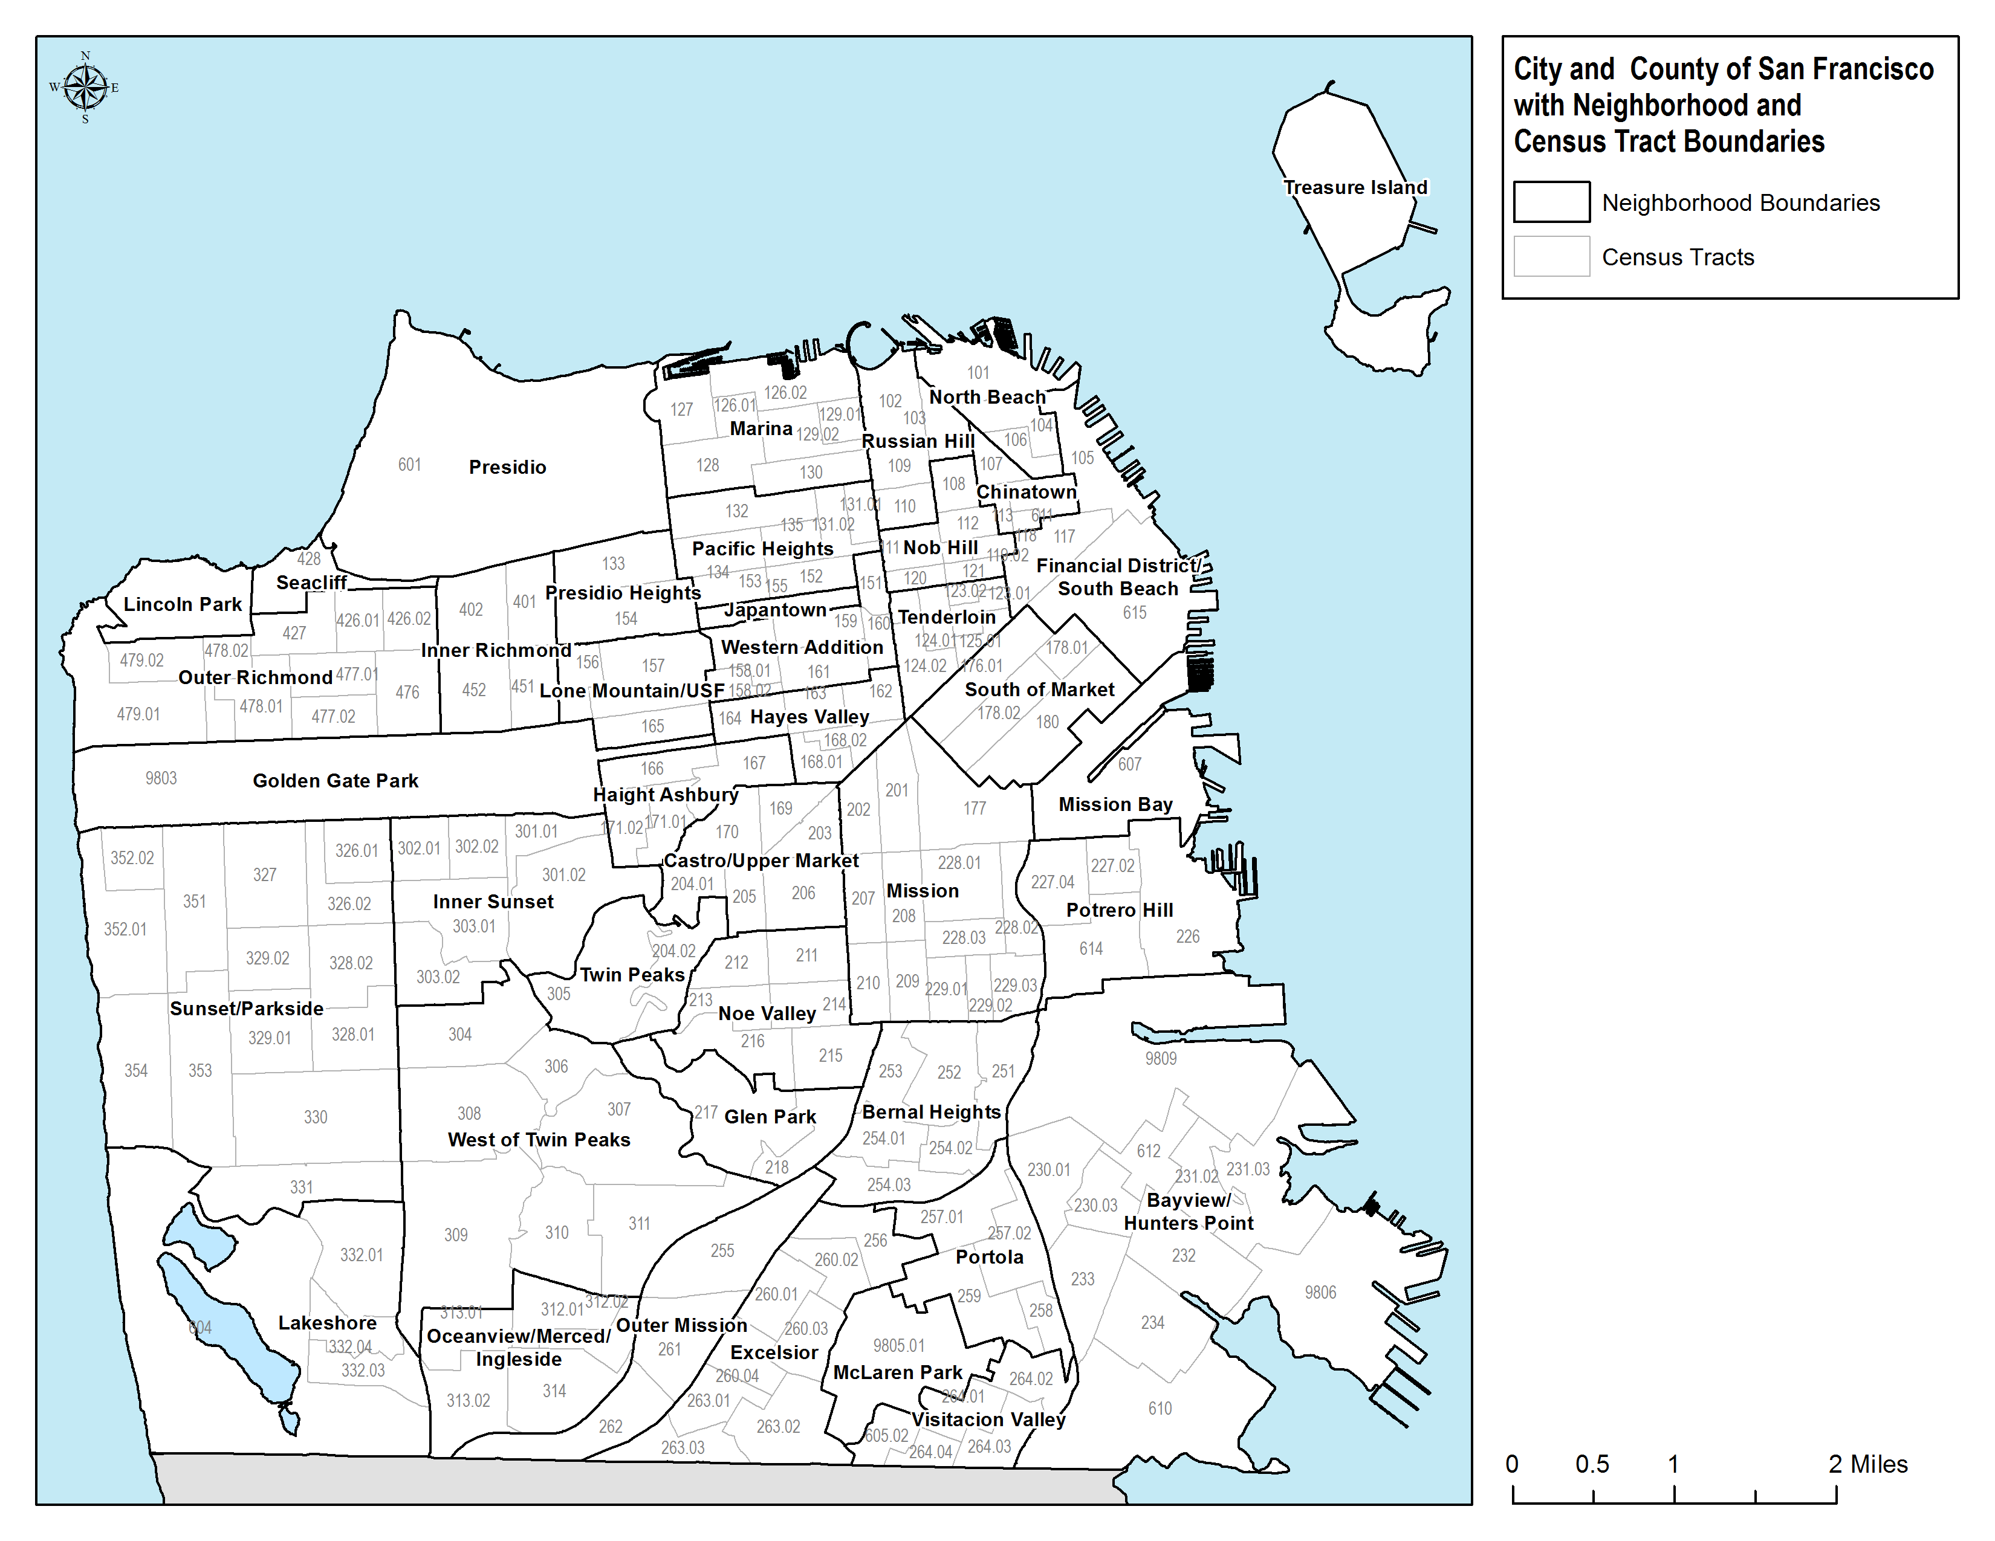

South of Market Community Stabilization Fund (SoMa Fund) Map

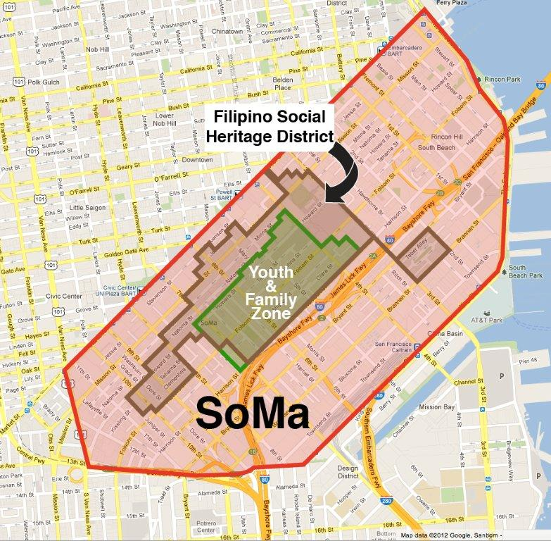
Map of San Francisco’s Priority Development Areas (PDAs)

