PROPOSAL COVER SHEET
(If legible, you may hand write this part of the proposal)
____________________________________________________________________________________

Agency Name:

Street Address:

City:

State: Zip Code:

Main Phone: Fax:
____________________________________________________________________________________

Project Name:

Project Description (one-liner):

Project Site Address (if different):

City:

State: Zip Code:
____________________________________________________________________________________

Executive Director:

Phone: Email:

Primary Contact Person (if different):

Phone: Email:
____________________________________________________________________________________

Select the funding source for which you are applying: |  | CDBG |  | HOPWA

Total Proposal Request: $

Total Capital Project Cost: $

Total FY 2019 or FY 2020 Agency Budget: $
____________________________________________________________________________________

I certify that the information provided in this proposal is true.

Signature of Executive Director | Date
BOARD OF DIRECTORS
(If legible, you may hand write this part of the proposal)
____________________________________________________________________________________

Name | Years on Board | Home Neighborhood | Job or Relevant Experience

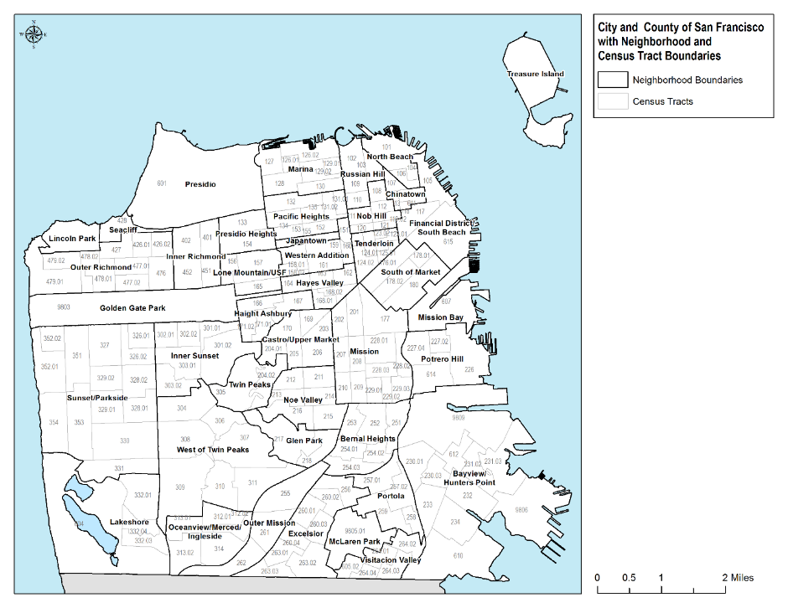
PROPOSAL NARRATIVE
(Must not exceed 10 pages)
____________________________________________________________________________________

- Project Design (worth up to 50 points)
- Describe your project, including which programs benefit from it.
- Describe those programs, including:
    - Any and all City investment
    - Community support and sources of funding
    - How they support the goals and objectives outlined in our 2015-2019 Consolidated Plan
    - A description of the target populations and neighborhoods they serve
- Describe how your project meets one or more of our grant objectives.
- List the facility improvement(s), along with their cost and the program(s) that will benefit from each.

Improvement | Cost | Program(s) Benefiting
1. | $
2. | $
3. | $
4. | $
5. | $

- List the neighborhoods served by the programs(s) benefiting from your project.
  - Estimate the percentage of clients served from each neighborhood.
  - Refer to our map for neighborhood names and boundaries (p.10).
  - For homeless and shelter programs, list the neighborhood of your facility.

Neighborhood | % of Clients
1.
2.
3.
4.
5.
TOTAL | 100%

- Complete the following table for each program that would benefit from your project. Using the last three columns, show how each program is eligible under HUD's low-income beneficiary requirements. Programs are eligible in only one of the following three ways. We can fund the removal of architectural barriers without association to an eligible program. Select from only one of the three columns for each program:
  - % Determined Low-Income: A program that collects and verifies data on family size and income so that it is evident that at least 51% of its beneficiaries are low-income. If you are using this column, enter the percentage of program beneficiaries that are low-income.
  - Area Benefit: A program that is available to all residents of a residential area, where at least 51% of the residents are low and moderate-income. Income projections must come from the most recent HUD income data. Population-specific programs such as youth and childcare programs cannot use Area Benefit. If you are using this column, make a check in the cell.
  - Exclusive: A program that only serves one of the following groups that HUD presumes to be low-income: Abused Children, Elderly Persons, Battered Spouses, Homeless Persons, Severely Disabled Adults, Illiterate Persons, Persons living with AIDS, and Migrant Farm Workers. If you are using this column, enter one of these groups.

Program Name | Program Description | # of Unduplicated Annual Clients | % Determined Low-Income | Area Benefit | Exclusive
1.
2.
3.
4.
5.
____________________________________________________________________________________

FY 2019 HUD INCOME LEVEL CHART

Family of: | 1 person | 2 persons | 3 persons | 4 persons | 5 persons | 6 persons | 7 persons | 8 persons
Extremely Low Income | $0 - 33,850 | $0 -38,700 | $0 - 43,350 | $0 - 48,350 | $0 - 52,250 | $0 - 56,100 | $0 - 60,000 | $0 - 63,850
Low  Income | $33,851- 56,450 | $38,701- 64,500 | $43,351- 72,550 | $48,351- 80,600 | $52,251- 87,050 | $56,101- 93,500 | $60,001- 99,950 | $63,851- 106,400
Moderate Income | $56,451- 90,450 | $64,501- 103,350 | $72,551- 116,250 | $80,601- 129,150 | $87,051- 139,500 | $93,501- 149,850 | $99,951- 160,150 | $106,401- 170,500
Above Moderate Income | $90,451  or greater | $103,351 or greater | $116,250 or greater | $129,151  or greater | $139,501 or greater | $149,851 or greater | $160,151 or greater | $170,501 or greater

If family is more than 8 people, for each person in excess of eight, 8 percent of the four-person base should be added to the eight-person income limit. (For example, the nine-person limit equals 140 percent [132 + 8] of the relevant four-person income limit.) Round income limits to the nearest $50.
____________________________________________________________________________________

- Describe any LEED certified or sustainable green building practices.
- Is your project for an existing facility or a new facility?
    - An existing facility houses ongoing service programs.
    - A new facility is an acquisition, or a renovation to house new or existing programs in a new space.

- Complete the following tables. You may add activities.

Activity | Start Date | End Date
- Establishing site control (e.g. owning, closing on a purchase, or establishing or extending a lease)
- Hiring an architect or other consultant
- Completion and approval of preliminary designs by the Mayor's Office on Disability (MOD)
- Applying for a building permit and license (if applicable)
- Bidding
- Construction
- Fundraising (if necessary)

Owner of Facility:
Facility/Site Size (in square feet):
Number of Stories:
Leased or Owned?
If leased, how long is the lease and how much time remains?
Total # of unduplicated clients served by program(s) within the facility:

- Organizational Capacity and Budget (worth up to 50 points)
- Describe the construction training and experience of your staff. If you are already collaborating with a team of professional organizations and service providers, such as planners, architects, landscape architects, and engineers, name the team members and describe each of their professional qualifications and experience with similar projects.
- Provide a list of capital improvement projects that your staff have managed in the last 5 years. Include the scope of work, cost, funding sources and length of time to complete each project.
- Do you have a long-term asset management plan, including an operating and maintenance reserve, for the facility?
  - If yes, describe how this grant request fits into the plan.
  - If no, describe your efforts to develop a plan and ensure future resources for facility improvements.
- What percentage of our grant can you match? If you cannot meet our guidelines for matching funds (p.3), what is your fundraising plan?
- Complete the following table:

- Requested Funds for Construction only: | $
- Requested Funds for Architectural and/or Engineering:  (not to exceed 15% of construction, and not available for new facilities) | $
- Total Grant Request (add 1+2): | $
- Total Project Cost | $

- Complete the following tables, listing all revenue sources and expenses for your project. For each revenue source, state whether you have secured the funding or not:

Revenue Source | Amount ($) | Secured
Total

Expenses | Amount ($)
Total

TOTAL SCORE ASSIGNED BY REVIEWERS: ____ out of 100

